Chapter 12, Problem 18.

If V_{an} = 220 ∠60° V in the network of Fig. 12.49, find the load phase currents I_{AB}, I_{BC}, and I_{CA}.

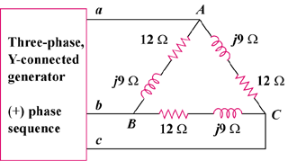

Figure 12.49
For Prob. 12.18.

